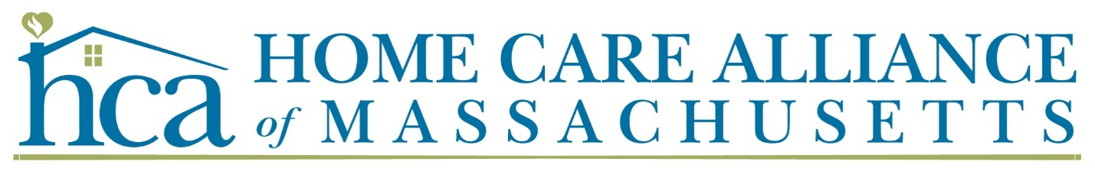

Our Time to Shine

2025 Star Awards & Innovation Showcase
Media Kit for Award Winners
Purpose: Celebrating top home care clinicians, aides, leaders, and innovators across Massachusetts.
Link: www.thinkhomecare.org

Overview
The Home Care Alliance of Massachusetts is proud to celebrate the exceptional individuals and programs that exemplify excellence in home care across the Commonwealth. Each year, “Our Time to Shine” recognizes outstanding aides, clinicians, managers, and innovators whose dedication and ideas move the industry forward.
Winners will be honored on:
Tuesday, June 11, 2025
Home Care Alliance of MA Annual Meeting
Location: Marlborough, MA
Hosted by the Home Care Alliance of Massachusetts,
Renee McInnes, Board President & Jake Krilovich, Executive Director
Mike Page, meteorologist and weather producer at WCVB News Center 5, Master of Ceremonies

Award Categories
Star Awards
- Aide of the Year
- Clinician of the Year
- Manager of the Year
- Home Care Champion
- Advocate of the Year

Innovation Showcase
Honors a program or initiative advancing patient care, staff well-being, or operational excellence.

Suggested Press Release Templates

(Detailed version)
FOR IMMEDIATE RELEASE
[Agency Name]’s [Employee Name] Honored at 40th Annual Our Time to Shine Awards
Home Care Alliance of Massachusetts Celebrates Excellence in Home Care
[City, MA — Date] — [Agency Name] is proud to announce that [Employee Full Name, Title] has been named the recipient of the [Award Title] by the Home Care Alliance of Massachusetts, as part of its Our Time to Shine celebration—now in its 40th year of recognizing excellence in the home care community.
[Employee Last Name] will be recognized at the Alliance’s Annual Meeting on Tuesday, June 11, 2025, in Marlborough, MA, alongside fellow award recipients from across the state.
This year’s honorees represent the heart of the industry: aides, clinicians, managers, advocates, and partners who bring exceptional dedication, compassion, and skill to their work every day. [Insert sentence highlighting the nominee’s specific contributions, career background, or impact.]
“We’re honored to celebrate [Employee First Name]’s achievements, which reflect the values and dedication that define our agency and the field of home care,” said [Executive/Manager Name], [Title at Agency].
According to Jake Krilovich, Executive Director of the Home Care Alliance of Massachusetts, the annual celebration is a chance to spotlight the people behind the mission.
“This celebration is about more than recognition—it’s about honoring the people who make home care possible,” said Krilovich. “The dedication, heart, and expertise these individuals bring to their work every day is what drives our mission forward. We’re proud to stand beside them.”

About the Home Care Alliance of Massachusetts
The Home Care Alliance of Massachusetts is a non-profit trade association of home care agencies that promotes home care as an integral part of the health care delivery system. Founded in 1969, the Alliance’s mission is to connect people and organizations to advance the health of communities through equitable access to quality care and services delivered in the home.
As of May 2025, the Alliance represents more than 200 agency members and nearly 100 allied and individual members statewide. Membership is voluntary, and while the Alliance is not a government agency, it plays a critical role in helping providers stay informed, navigate regulation, and deliver high-quality, patient-centered care.
The annual Star awards were established in 1989 to recognize and celebrate those individuals and organizations that have done the most to advance the home care industry in Massachusetts, and who exemplify the compassion and commitment that is the essence of home care. Now celebrating its 35th year, the Our Time to Shine Awards program highlights the people and programs making meaningful contributions to home care, from outstanding frontline caregivers to forward-thinking innovators.

(Shorter)
FOR IMMEDIATE RELEASE
[City, MA — Date] — [Agency Name] is proud to announce that [Employee Full Name, Title] has been honored with the [Award Title] by the Home Care Alliance of Massachusetts as part of its annual Our Time to Shine Awards.
This recognition celebrates [his/her/their] [compassion, leadership, clinical excellence, or innovative thinking] and meaningful contributions to the home care community. [Insert a sentence about the recipient’s achievement, career, or specific impact.]
“Recognition from the Home Care Alliance reflects the quality and commitment our staff bring to clients every day,” said [Executive/Manager Name], [Title]. “[First Name] represents the very best in home care.”
Award recipients will be formally celebrated during the Alliance’s Annual Meeting on June 11, 2025, in Marlborough, MA.

"This celebration is about more than recognition - it's about honoring frontline workers who make it possible for people to stay in their homes and communities with high-quality care at home," said Jake Krilovich, Executive Director of the Home Care Alliance of Massachusetts. “The dedication, heart, and expertise these individuals bring to their work every day are what drive our mission forward. We’re proud to stand beside them.”

About the Home Care Alliance of Massachusetts
Founded in 1969, the Home Care Alliance of Massachusetts represents home health, hospice, and private care agencies statewide, advocating for high-quality care delivered at home. More information is available at www.thinkhomecare.org.

Agency Media Contact:
[Agency contact name]
[Title]
[Phone] | [Email]
Alliance Contact (for reference):
Leslie Hammond
Director of Membership & Marketing
Home Care Alliance of Massachusetts
lhammond@thinkhomecare.org | (617) 482-8830

Visual Assets for Social Media & Print
- Award logo badge – PNG format (for email signatures, social posts)
- “Our Time to Shine 2025 Winner” customizable graphic
- HCA logo – high resolution
- Optional Canva templates available upon request

Sample Social Media Posts
Editable Square for Socials, on Canva:

LinkedIn/Facebook:

We’re thrilled to announce that [Employee Name] has been honored as [Award Title] at the Home Care Alliance of Massachusetts' Our Time to Shine Awards!
Their work is a shining example of excellence in home care.
Join us in celebrating on June 11 at the Alliance Annual Meeting in Marlborough.
#HomeCareHeroes #HCAwards #OurTimeToShine

Twitter/X:

🎉 [Name] won [Award Name] from @HCAMass!
Join us in Marlborough on June 11 to celebrate at the Annual Meeting.
#OurTimeToShine #HomeCareExcellence

About the Home Care Alliance of Massachusetts
The Home Care Alliance of Massachusetts is a non-profit trade association of home care agencies that promotes home care as an integral part of the health care delivery system. Founded in 1969, the Alliance’s mission is to connect people and organizations to advance the health of communities through equitable access to quality care and services in the home.
As of May 2025, the Alliance represents more than 200 agency members across the Commonwealth and nearly 100 allied and individual members. Membership is voluntary, and while the Alliance is not a government entity, it plays a vital role in helping providers navigate regulation, improve care, and grow sustainably.
The Our Time to Shine Awards program began four decades ago to highlight exceptional work in a field that too often goes unnoticed. From home health aides to executive directors and innovative care models, the awards now span multiple categories and include an annual Innovation Showcase spotlighting breakthrough programs.

Need Help Sharing the News?
Contact Leslie Hammond, Director of Membership & Marketing
📧 lhammond@thinkhomecare.org | 📞 (617) 482-8830
We’re happy to help personalize your graphics, customize a press release, or assist with media outreach.

Alliance Logos

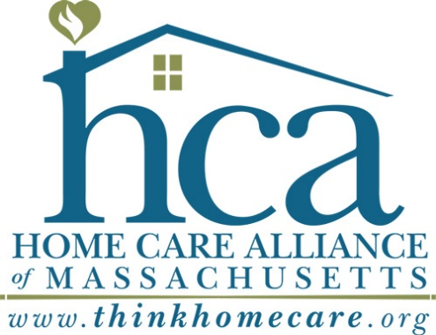

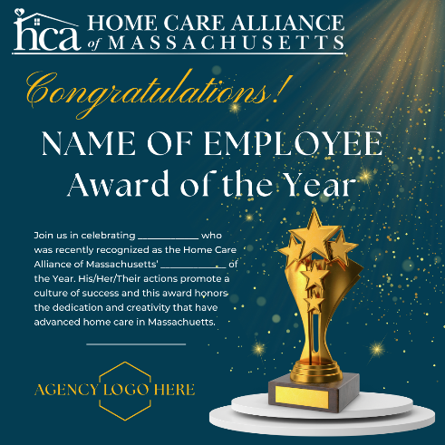


To create your own, access this shared Canva Document:
https://www.canva.com/design/DAGnhnEjYTY/cap3jwJyguDi3k_tknfzSg/edit?utm_content=DAGnhnEjYTY&utm_campaign=designshare&utm_medium=link2&utm_source=sharebutton

